



A Product of
Accurate Monitoring &
Real-time Processing of
Employee Time
Complete Time & Attendance Solutions

- TimeCheck System Architecture
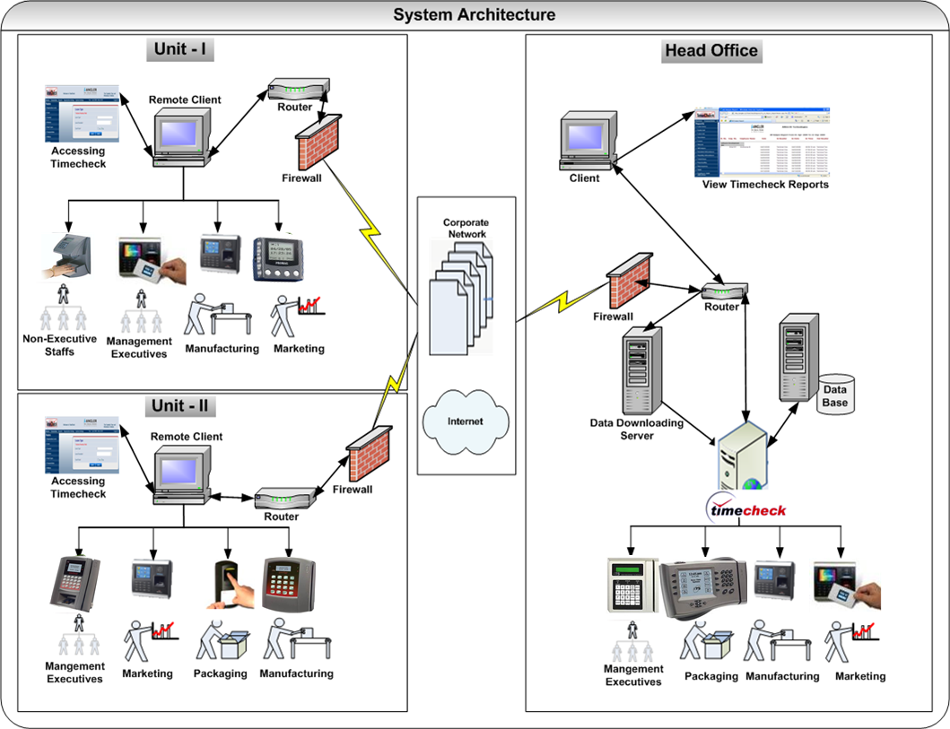

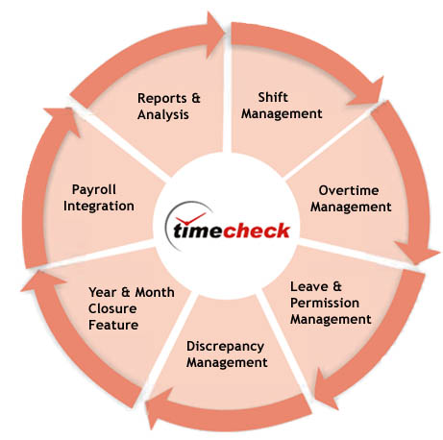
Key Functional Modules

2. TimeCheck Overview:

TimeCheck is a web enabled software tool and a global product for processing time recorded using any Industry standard smartcard or Biometric terminals across the organization including remote locations over intranet or internet. Known for its adaptability, to the organization’s business rules, TimeCheck helps managers to take timely decisions in running their operations by simplifying time-consuming routine of processing their employees’ attendance data, against the shifts and approved leaves to arrive at normal time and overtime. TimeCheck also ensures on-time payment of salaries, when integrated with payroll package. With greater flexibility over organization’s hierarchical reporting structure, TimeCheck protects sensitive employee information with comprehensive security layers.
3. Why TimeCheck?
- Accurate time recording information for specific areas.
- Ability to use the data stored for management purposes.
- Potential to link into automated payments for Payroll.
- Operates according to Industry standard terminals, Smartcard & Biometric.
- Suits Small, Medium and Enterprise organizations.
- Excellent Tool for processing Time data like finding out the normal time and over time validating against the shifts, leaves, holidays, etc.
- Simplifies the time-consuming routine of processing attendance data.
- Reduces human errors & delays.
- Protects both the employer’s and employee’s interests for a successful business.
- Shift Management:

- Shift Management helps you define the various shifts for a company
- Defines the combination of different work shifts (known as Shift Pattern) while allocating shifts to employees
- Lists out all the previously entered combination of work shifts including Shift Pattern Name, Company Name and No. of Days
- Helps you to rotate the defined work shifts using Shift Roster in a sequential manner.
- TimeCheck has flexible shifts definition
- Acquires excellent user-friendly shift allocation
- TimeCheck helps you to rotate the shift patterns for enterprises conveniently
- TimeCheck helps you to allocate temporary shifts and shift exchanges in a easier manner
- Generation of various shifts allocated for an employee(s) for a specific time period or summarization of his/her permanent schedule report to know the employee’s current schedule pattern allocated by the management
- Overtime Management
- Overtime Management helps you in the online calculation of overtime
- TimeCheck enables you in the flexible calculation to different segments
- TimeCheck helps you to implement online approvals and controls based on organization needs
- TimeCheck offers excellent options to en-cash or in-lieu days
- Overtime Report helps the Admin or the User having privileges to view report displaying Employee ID, Employee Name, Dates, Worked Hours, OT hours, Weekly off OT hours, Holiday OT hours for each employee & each date between the selected periods
- The user can generate Individual Employee Report, report based on the Organization Level and filter the reports for an Employee Category and Employee Type
- Leave / Permission Management
- Leave / Permission Management allows the company administrator or user having privileges to define and view various Leave Types (E.g. Casual Leave, Sick Leave, Earned Leave, Medical Leave etc.) applicable to any levels in the organization
- TimeCheck also helps in defining the different leave policies offered to different grades/levels of employees with various search filters so that the policies are applicable to a set/group of employees
- TimeCheck helps the authorized person (like admin, HR) to raise and view the leave request details of employees
- With the help of various search criteria (e.g., employee type, duration, etc), the authorized person can view the details of the leave/permission of executives
- TimeCheck helps you to define the various leave quotas defined and verify for every transaction
- Designed to meet global needs and standards
- Discrepancy Management
- Manual Time Entry allows the authorized person to manually add the Shift In and Out Time of an employee for a particular day.
- The following are the cases in which the authorized person can enter shift in and shift out manually:
- If an employee forgets to bring swipe card
- If an employee missed out to punch either In or Out
- If an employee comes late to the company due to delay in transportation
- If an employee has attend to an official duty/job assigned outstation
- Easy to handle group manual entries for unpredictable situations like bus late or important events
- The authorized person can manually add, view and modify the Manual Time Entries.
- This also allows the authorized person to view the discrepancy entries for employees & close the discrepancy entries which has been occurred due to employees failing to punch
- The generated report helps authorized person to view the Employee ID, Employee Name, Date & Time of Odd punches (In Time without Out time or Out Time without In time) for each employee for a particular day between the selected periods
- Highly flexible and Secured for the various organization demands
- Flexible handling for Odd punches using various filter options
- Discrepancy Entry enables authorized person to view and close the discrepancy entries for employees to make month closure process without disturbance
- The authorized person can able to exclude or include the discrepancies based on their needs.
- Month Closure
- Month Closure enables authorized person to process the data by proper verification of discrepancy and re-processes the data based on the changes
- TimeCheck also allows the authorized person to view report that shows Employee Number, Employee Name, Hours Worked, OT during Week Days, OT during Weekly Off, OT on Holidays, Early Out, Late In, Less hours worked, Hours Extra, Leave Days, Present Days, Absent Days and Holidays for each/all Employee(s) based on the search criteria
- TimeCheck includes Automatic or Batch process to conveniently synchronize with the Payroll & HR Applications
- TimeCheck is flexible and has user defined date and month for processing
- The processed data can be exported in the form of Excel, CSV & XML formats for Payroll integration & other third party Applications.
- TimeCheck is reliable and user friendly with pop-up discrepancy reports
- Year Closure
- Year Closure helps authorized person you to calculate Leave arrears, Current Quota, Leave Taken and leave Available for the next successive year for each employee
- After the year closure, the Leave Policies which have been defined for the year is locked and the existing policies can be automatically assigned for the next successive year
- With the help of the Year Closure report, the authorized person can view leave quota, remaining number of leave available in a particular year
- TimeCheck is flexible and has user defined date and year for processing
- TimeCheck is reliable and user friendly with options to view the leave encashment at any time
- Other Useful Features
- TimeCheck is flexible to handle the Additional Weekly Off
- TimeCheck can handle the Company Closing time during Inevitable & unpredictable situations like Strike, Call off, etc
- TimeCheck can manage Common Holidays and Local Holidays in an easier manner
- TimeCheck helps to calculate Bonus Leave feature for the first N number of absent days
- TimeCheck can handle Flexible and Non-Flexible Shift Timings
- Bilingual Feature (English & Arabic)




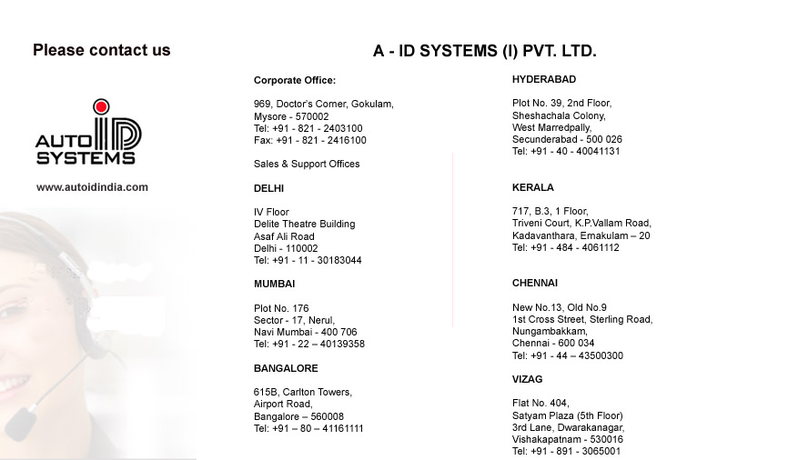
Complete Time & Attendance Solutions
A Product of

